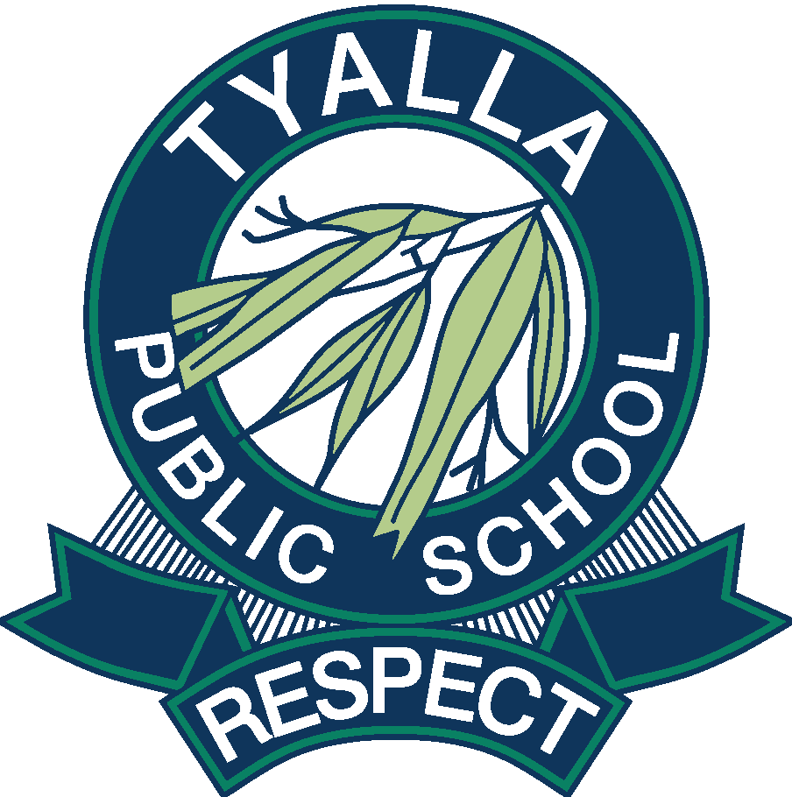
Tyalla P&C Association

26 Joyce Street, Coffs Harbour NSW 2450
Ph 02 6652 4488 I Fax 02 6651 4096 I Email tyallapandc@iinet.net.au
www.tyalla-p.schools.nsw.edu.au

Tyalla P&C Association Code of Conduct
The Code of Conduct applies to all financial members, volunteers and employees (‘members’) of Tyalla Parents & Citizens Association (‘P&C Association’) while undertaking any role or activity related to the Tyalla P&C Association.
Principles
The Code of Conduct is based on the following fundamental ethical principles:
Respect for the Law
Tyalla P&C Association members, in common with all citizens, are under the jurisdiction of the laws of the State and the Commonwealth and are obliged to observe such laws.
Respect for all Persons
Tyalla P&C Association members are expected to treat students, school staff, and all members of the community equitably with dignity and respect. This involves, but is not limited to, the following:
- Tolerance of the views held by others which are different from your own
- Courtesy and responsiveness in dealing with others
- Fairness in supervising and dealing with other members
- Making decisions that are procedurally fair to all people according to the principles of natural justice
- Not discriminating on grounds such as gender, sexual orientation, race, ability, cultural background, religious status, marital status, age or political conviction
- An awareness and respect for cultural difference
- Engaging in rational debate allowing for alternative points of view to be expressed
- Not engaging in behaviour that might reasonably be perceived as harassment, bullying or intimidation
Integrity
Tyalla P&C Association members shall be honest in carrying out their duties and avoid conflicts between their private interests and their P&C Association roles and responsibilities with respect to:
- Personal relationships
- Financial relationships
- Receipt of gifts
- Employment
- Use of confidential information obtained in the course of P&C Association duties
- External activities and public comment
Diligence
Tyalla P&C Association members shall carry out their duties in a professional and conscientious manner. This involves:
- Carrying out official decisions and policies faithfully and impartially
- Seeking to attain the highest possible standards of performance
- Exercising care for others in P&C Association related activities
- Ensuring outside interests do not interfere with a P&C Association member’s duties or responsibilities
- Adhering to professional codes of conduct where applicable being encouraged to report fraud or corrupt conduct to an Office Bearer of the P&C Association and/or external authorities
Working with Children
The Tyalla P&C Association adheres to the government’s Child Protection Act & Regulation (Working with Children Check) legislation and relevant procedures
Conflict of Interest
- P&C Association members must declare interests which a conflict, either perceived or actual, with your P&C Association duties and activities that might benefit the private interest of a member/s of the P&C Association.
- P&C Association members must always act in the best interest of the P&C Association and adopt a process to disclose and address the potential conflicts.
- A conflict of interest may include, but is not limited to, existing individual interests or a benefit, professional ethics, personal or professional relationships, financial or proprietary interests. A few examples of Conflict of Interest:
Example 1
Personal or Financial Interest: Joe, an Office Bearer of a P&C Association owns a Building & Maintenance Company. During the P&C Association meeting, he recommends his company for an upcoming building work the P&C Association is considering to undertake as he believes he can offer the best competitive price being in the building business. However, he does not disclose the ownership of the company. Does Joe have a Conflict of Interest?
Yes. It is Joe’s duty to act in the best interest of the P&C Association and not his own interests. To promote the profit interest of his own company and receive remuneration is contrary to his role and responsibilities as an Office Bearer of a P&C Association as stated in clause 5 of the Standard and the Prescribed Constitution. There is clear Conflict of Interest as Joe failed to disclose his personal business interests for gaining an undisclosed profit.
Example 2
Non-Financial Interest involving some close relationships (not limited to partners, family and friends): Vicky, a Canteen Manager of a P&C Association, suggested at a P&C meeting, an online fresh fruits and vegetables vendor she knew could offer a more competitive price than the existing supplier. She discloses that her son works as a delivery driver for the vendor. Is there a Conflict of Interest?
Yes. Indirect and or direct employment of an immediate family member, friend or a close acquaintance is a conflict of interest. In this case, there is a clear indirect financial gain as her son will benefit from the extra work.
Conflict of Interest Disclosure
- Where a Conflict of Interest has been identified, it is expected that the conflict must be brought to the attention of the Office Bearers and the members, and be disclosed or addressed in a meeting.
- Breaching and/or violating the Conflict of Interest may result in removal from the P&C Association in line with Code of Conduct policy.
How to deal with a Conflict of Interest
- Identified Conflict of Interest must be carefully managed by impartial decision-makers, who are not involved in the conflict.
- Minutes of meetings should reflect how the conflict was raised, addressed and managed; and the outcome be disclosed to all members.
- The person(s) with the Conflict of Interest may be refrained from participating in all formal or informal discussion, debate and voting; and their duties be re-assigned until a resolution has been found.
- The person(s) with the Conflict of Interest may be restricted to access confidential information and sensitive documents relating to the conflict of interest.
- In the event where a Conflict of Interest is very significant and prevents the person(s) with the Conflict of Interest to perform their role and responsibilities, the P&C Association may ask that the person(s) involved with the conflict relinquish their personal interest that creates the conflict and/or resign from their P&C Association role.
Privacy and Confidentiality
- P&C Association must adhere to the Australian Privacy Principles contained in the Privacy Act of 1988.
- P&C Association must recognise that the privacy of any individual’s personal identifiable information must not be divulged or shared under any circumstances without the individual's written consent within or outside the P&C Association, unless there is a lawful authority for its disclosure.
- P&C Association must take all reasonable steps to ensure confidential data, documents and personal information of any individual is protected from misuse, loss and unauthorised access, and/or disclosure.
- All personal and sensitive information must not be viewed, shared or distributed to any person/s other than the Office Bearer/s who have responsibility of such information of the P&C Association.
- All personal and sensitive information when no longer required must be disposed of securely.
- Confidential information of a P&C Association must not be used, disclosed, copied, published or removed by any member of the P&C Association.

Grievances, Complaints and Procedures
Breaches of this Code of Conduct or other policies of the P&C Association will be addressed by way of the Grievances, Complaints and Procedures Policy. Violations may result in removal from Tyalla P&C Association.
As adopted by the Tyalla P&C Association General Meeting, Date:
Signed President: NAME:
Witnessed Secretary: NAME: ______________________________

